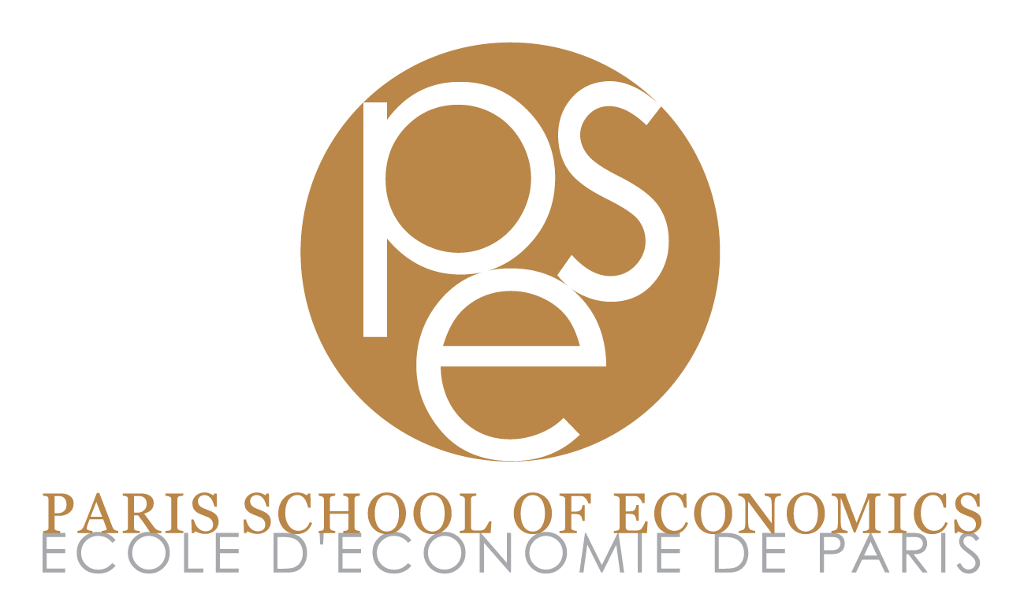

Name:

Affiliation:

Current Position:

Please answer the following three questions:

1. Explain why you are interested by a position at the Paris School of Economics (150 words maximum).

2. Which research group(s) of the Paris School of Economics would you be willing to interact with? Please explain why (150 words maximum). See https://www.parisschoolofeconomics.eu/en/research/pse-research-groups/

3. Have you ever had any connection to economics profession or economics education in France? If yes, please provide a detailed description (150 words maximum).

